Tutorial-10

Modules name:Flipkart
Test Case ID:Flipkart
Environment Information:os:macos(Sequoria 15.5)system : laptop(macbook air)webpage URL:FlipkartFlipkarthttps://www.flipkart.com › freedon › sale

Screenshort:
Scenario 1:

Demo login page:Flipkart website opened
Test Steps:1a
1.open the flipkart
2.Login the page
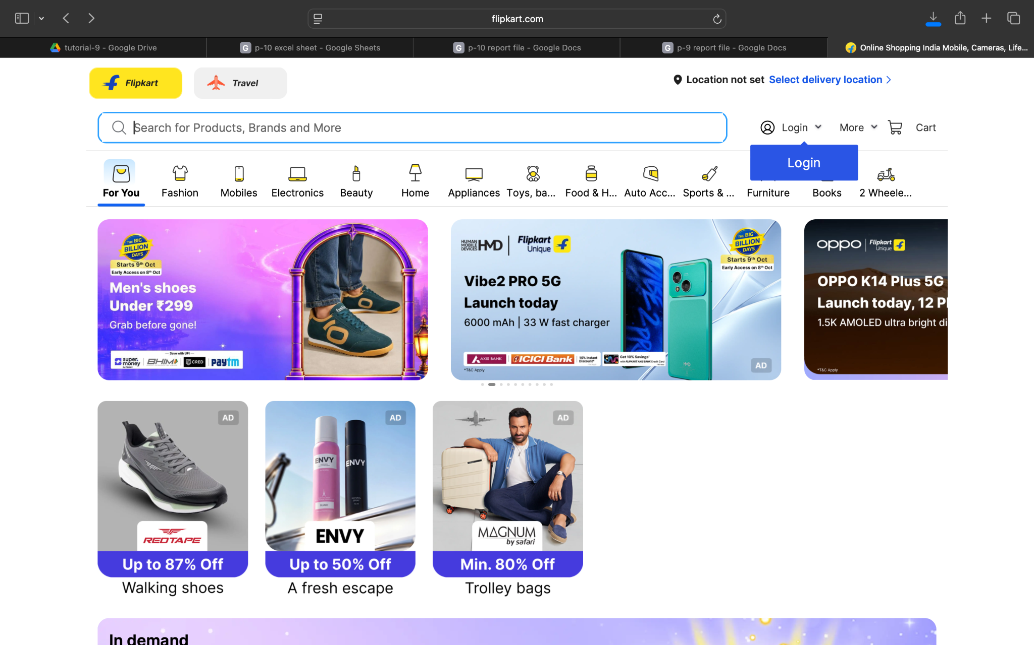

Demo login page:Flipkart open and login the account
Test Steps:1b
1.open the Flipkart website
2.check the browser on open the page
3.open the login page

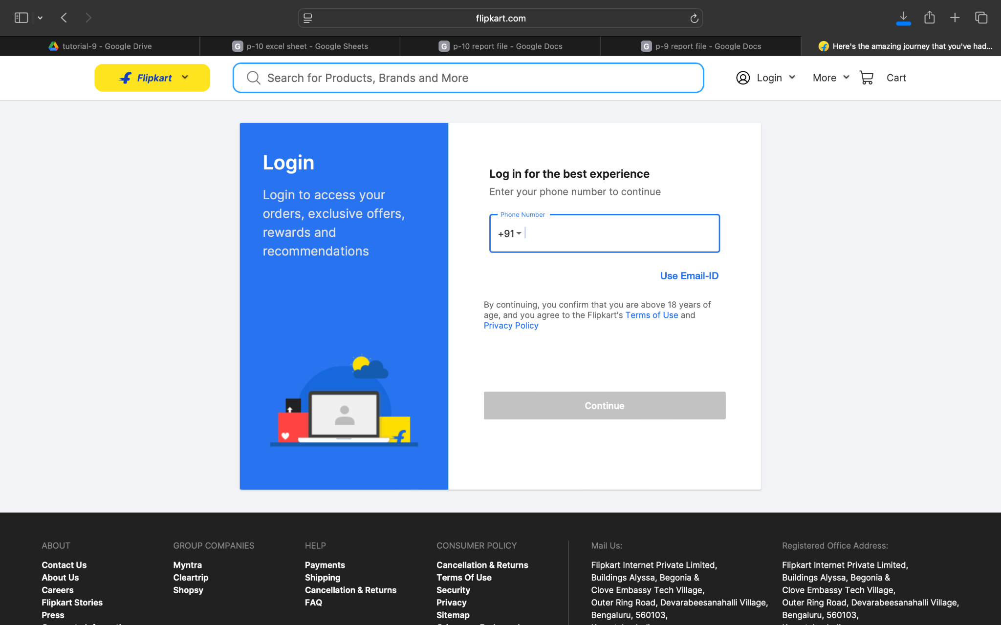

Demo login page:Flipkart open and enter the valid email & user mobile number
Test Steps:1c
1.open the Flipkart website
2.open the login account page
3.enter the valid email id & user mobile number
4.open the user flipkart account
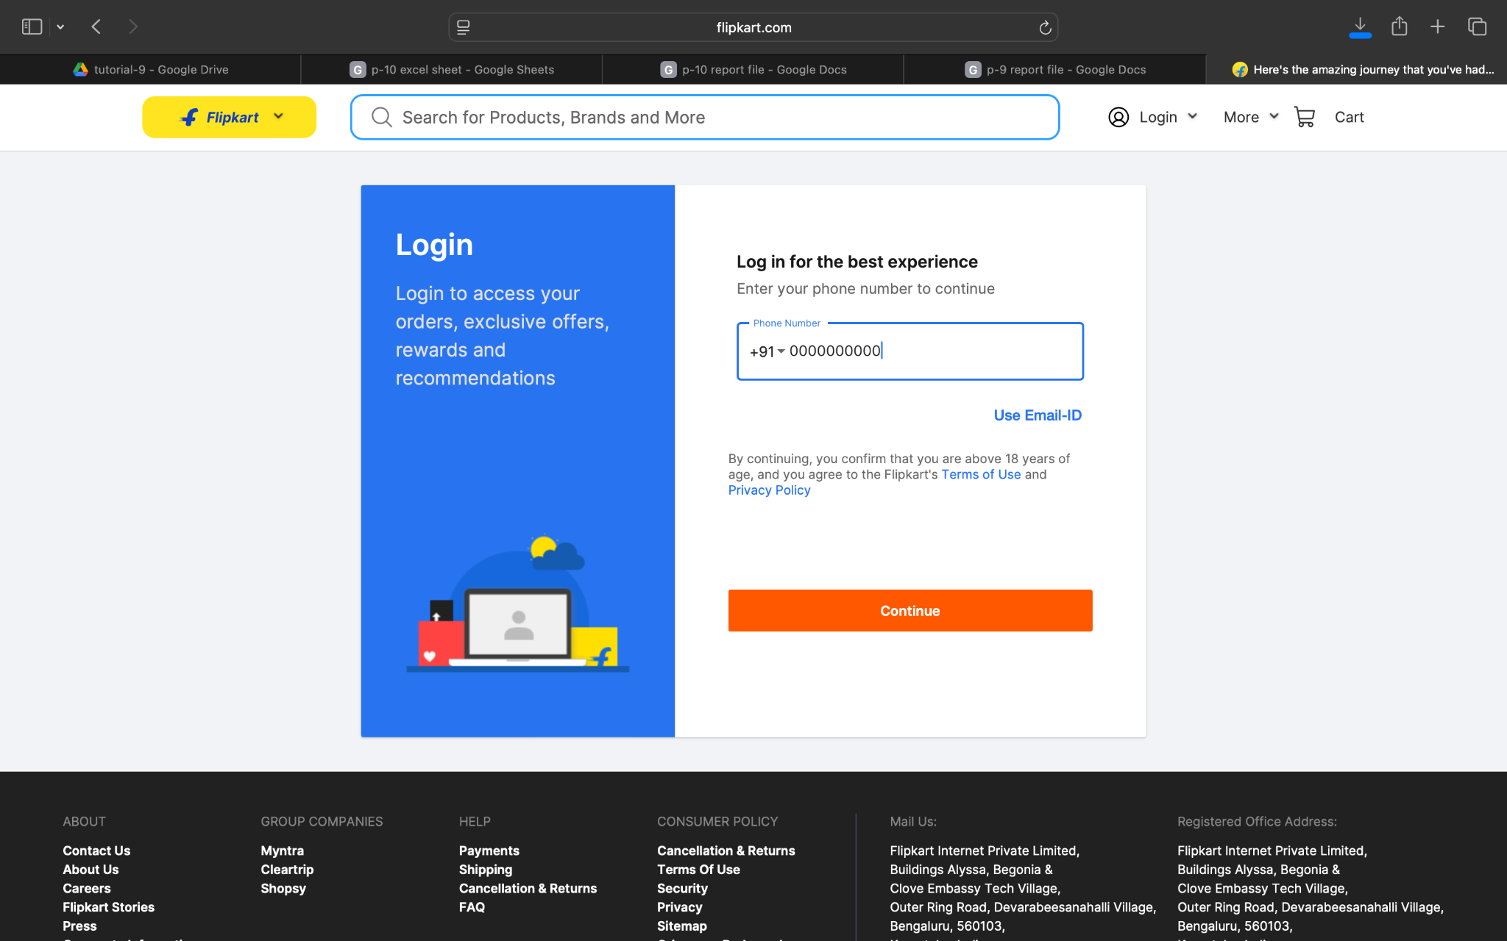

Demo login page:Flipkart account and user invalid email id and mobile number
Test Steps:1d
1.open the Flipkart website
2.check the browser on open the page
3.enter the valid email id and mobile number
4.but user fillup the invalid email id and mobile number
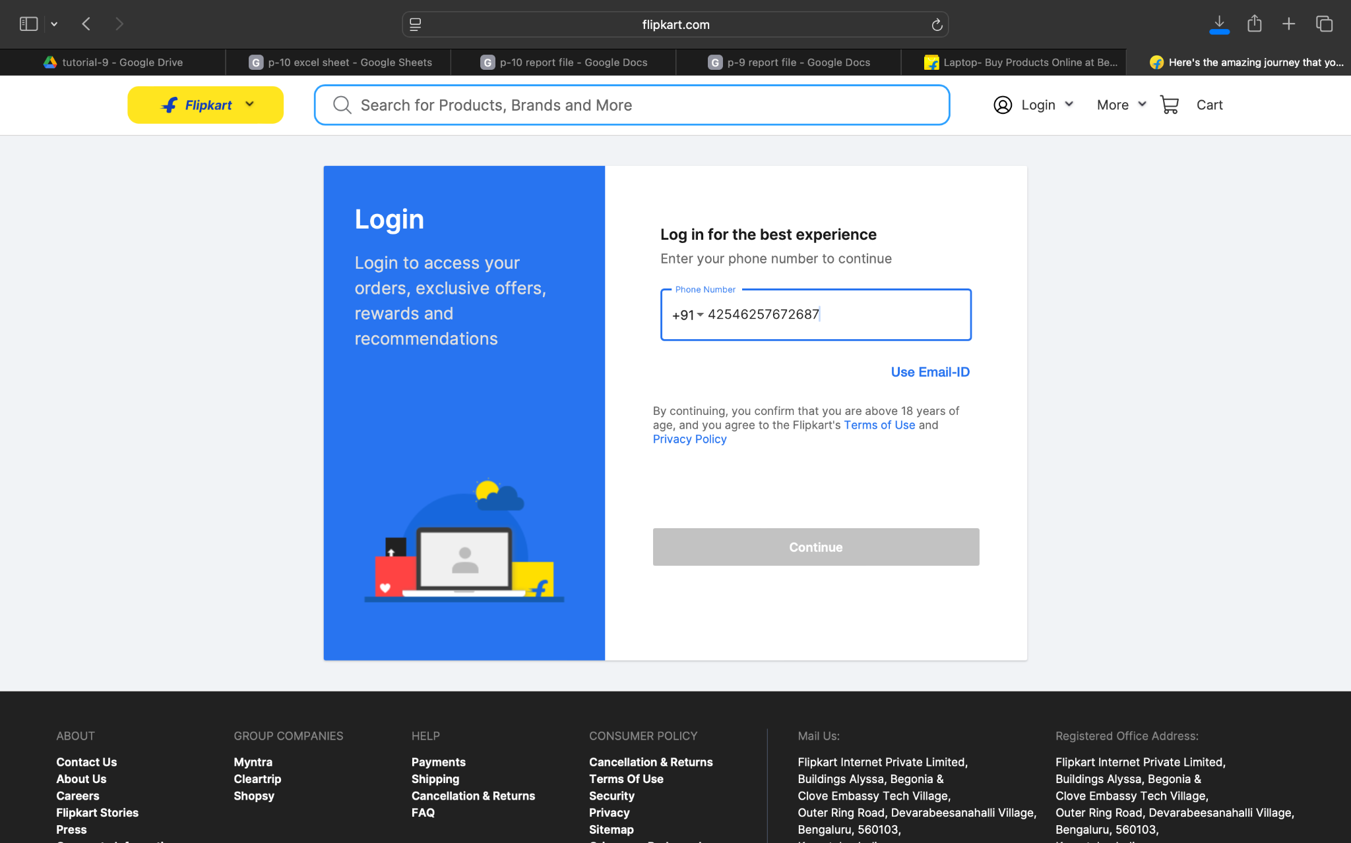

Demo login page:Flipkart website opened and Search for a product
Test Steps:2a
1.open the OrangeHRM demo website
2.check the browser on open the page
3.enter the valid email id and mobile number
4.flipkart account create and open the page
5.Search the product
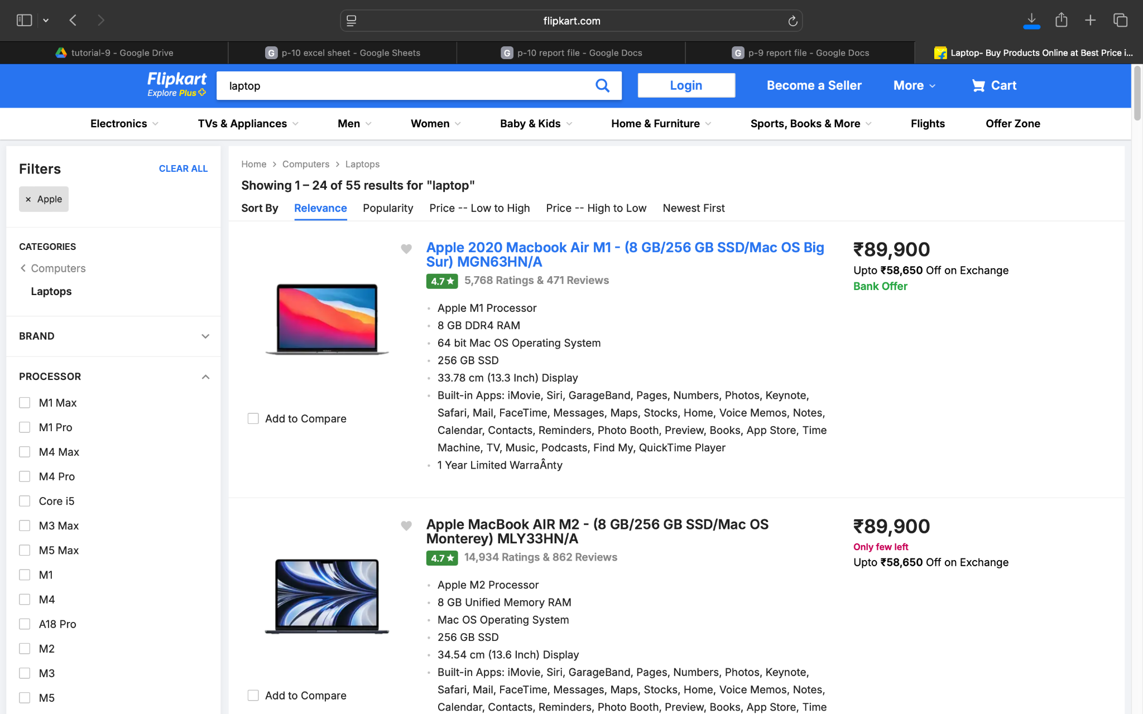

Demo login page:Flipkart website opened and open the search product
Test Steps:2b
1.open the OrangeHRM demo website
2.check the browser on open the page
3.enter the valid email id and mobile number
4.successfully login the page
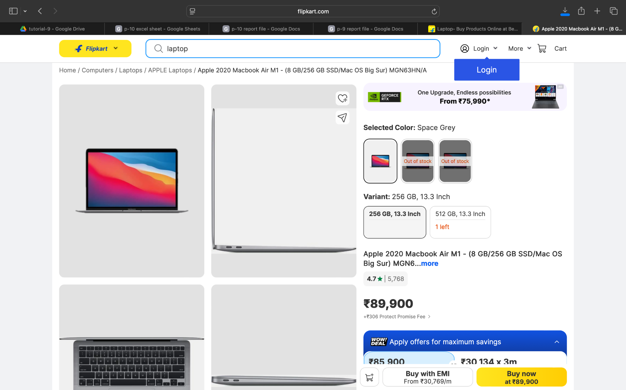

Demo login page:Flipkart website open and open the product details to add to cart
Test Steps:2c
1.open the Flipkart website
2.check the browser on open the page
3.enter the valid email id and mobilenumber
4.successfully login the page
5.search the product
6.verify the product
7.product add to cart

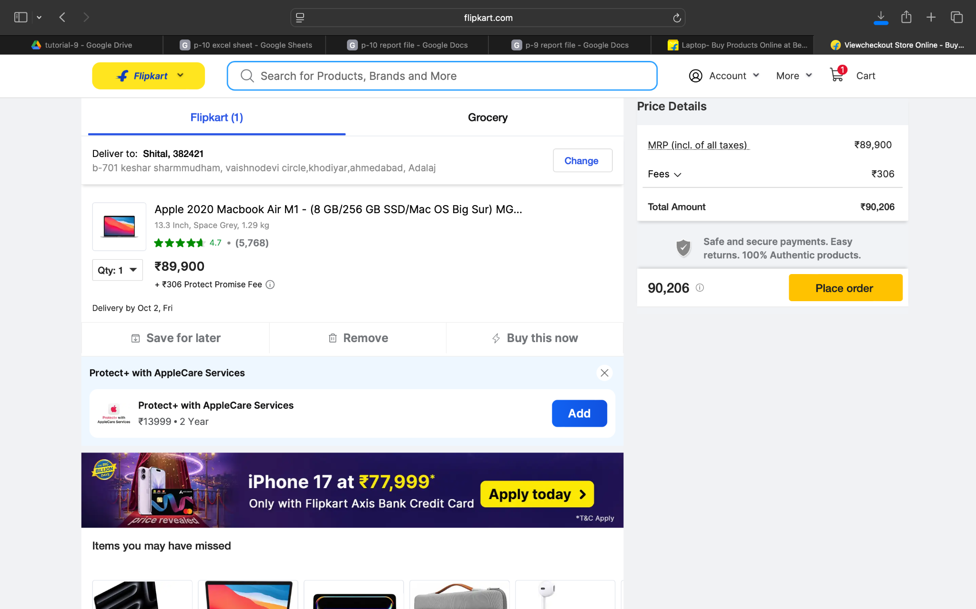

Demo login page:verify the product
Test Steps:2d
1.open the Flipkart website
2.check the browser on open the page
3.enter the valid email id and mobile number
4.successfully login the page
5.search the product and add to cart
6.open the cart and verify the product

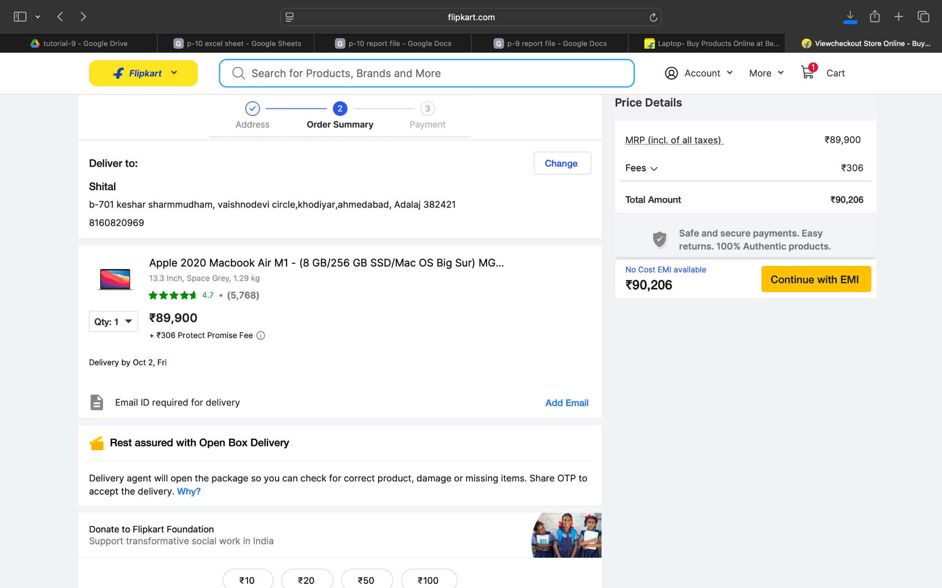

Demo login page:verify the product and removes the cart
Test Steps:3a
1.open the Flipkart website
2.check the browser on open the page
3.enter the valid email id and mobile number
4.successfully login the page
5.search the product and add to cart
6.open the cart and verify the product
7.remove the cart

Demo login page:Flipkart logout account successfully
Test Steps:3b
1.open the Flipkart website
2.check the browser on open the page
3.enter the valid email id and mobile number
4.successfully login the page
5.search the product and add to cart
6.open the cart and verify the product
7.remove the cart
8.logout the account

